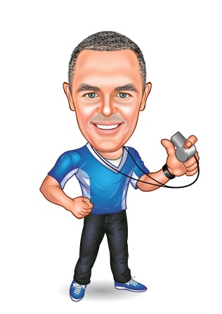
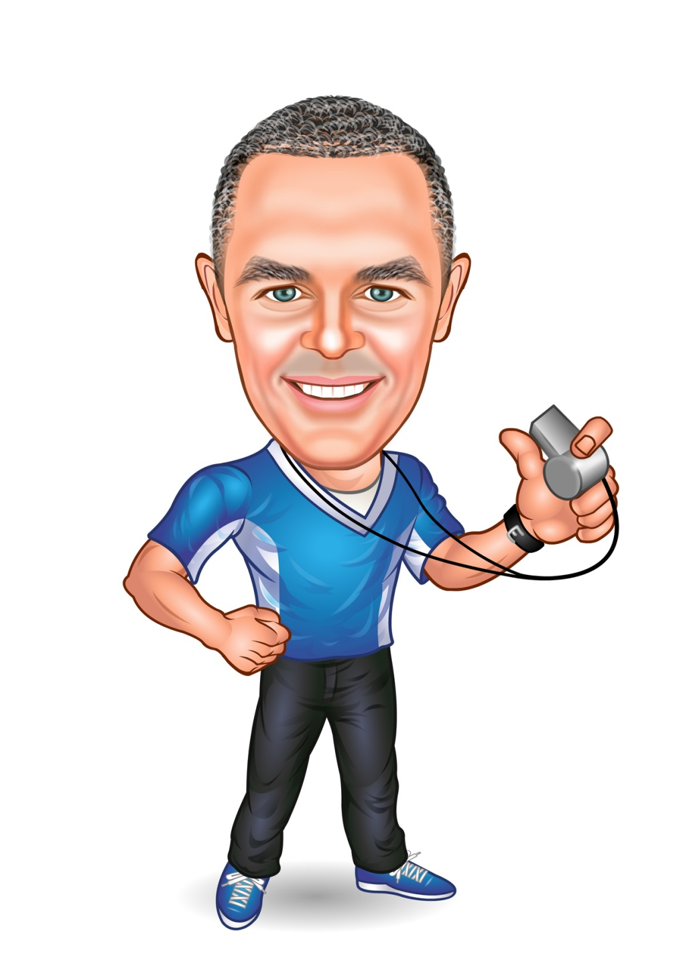

Planning for 2022

With

COACH MICHAEL

“The Future Belongs to Those Who Have the Courage to Live Their Dreams.”

~ Eleanor Roosevelt
Read through this
workbook in its entirety to get a feel for the
overall content and all things to consider.

Take the time to complete
the following
work as thoroughly
and detailed as possible,
the information will
help guide you to continued growth through 2022 and beyond.

Have Fun & Enjoy the Road to Success!

Coach Michael

#1 - REVIEW OF LAST YEAR

  - YOURSELF – Review 2021
Let’s start with YOU! What events or experiences during the year have ‘changed’ your thinking or outlook?

My experience was… | It has made me…
1.
2.
3.
4.
5.
6.
7.
8.
9.
10.
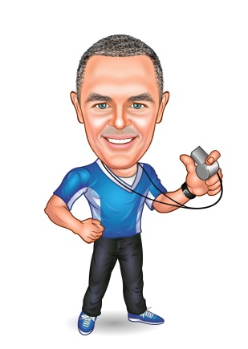
Socrates said, “An unexamined life is not worth living.”
A great tool is to ‘journal’ your year. Each day, write just one thing that’s happened, to move you towards your goals. You can also review it, during times when you are a bit ‘down’; you’ll see that every day you manage something to move you forward.

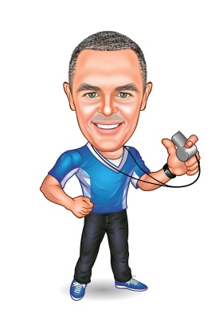
1.2 Short Falls – Review 2021
If the ‘short-fall’ can be blamed on someone or something else, then you’re limited in your control! So always ask yourself “How am I responsible for the outcome?”
Was there anything on your list to achieve in 2021 (personal or business), that you didn’t accomplish? Why didn’t it happen? What needs to change in order for it to happen in 2022 (if it’s still a goal?)

What didn’t get accomplished? | What needs to change about YOU in order to accomplish things like this in the future?
1.
2.
3.
4.
5.
6.
7.
8.
9.
10.

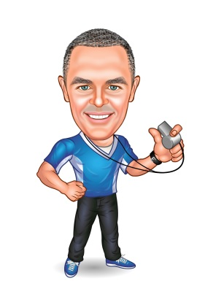
Remember to check last year’s bucket list for anything you need to ‘check off!

1.3 Accomplishments – Review 2021
Take a look at what has changed in your business and life. What activities and accomplishments do you think demonstrate the success and progress of the business and your personal life?

1.
2.
3.
4.
5.
6.
7.
8.
9.
10.
11.
12.
13.
14.
15.

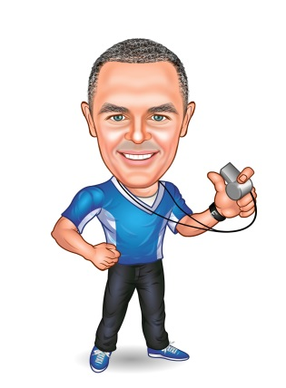
1.4 Gratitude’s – Review
I’m grateful for:
- A Wonderful Understanding Wife;
- Kids that love being with me;
- My awesome backyard;
- Living in Sunny Florida;
- The Opportunity to Impact others!
Between ‘reviewing’ and ‘planning’ comes the ‘present’. It’s here that we need to reflect on what we’re grateful for. Expressing what you’re grateful for will really help you ‘connect’ with the feeling of success. Make a list of what you love that’s already in your life… big or small! “Live in the Attitude of Gratitude!”

I’m grateful for…

1.5 Your ‘Reverse Bucket List’
It’s nice to take a look back at your ideal life. We seem to always be looking forward to what we want, however it’s very beneficial to look back at what we’ve done. Let’s record all the adventurous and enjoyable things we have experienced in our lives up till now.

Have fun in realizing that you have lived a wonderful life!

My ‘Reverse Bucket List’

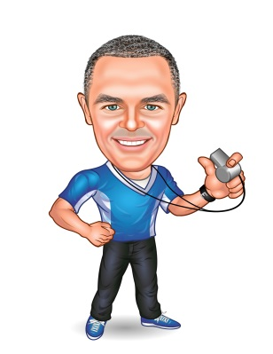
- Dive the Great Barrier Reef;
- Alaska back-country trip.
- Dive with Hammerheads in Mexico;
- Vacation in Italy.
#2 – The Future

2.1 Visualization – Your ‘Bucket List’
Every year, it’s nice to take a look into your future and really imagine your ideal life. I love the quote “Live the life you imagine; move confidently in the direction of your dreams”. Let’s start with 40 things you want to accomplish in your lifetime… it’s often called your ‘Bucket List’. Don’t be skeptical, this exercise is very important, if you plan to enjoy more than you have in the past. If you’ve got a bucket list already, you’ll
be wanting to add to it!

If you’re having problems with inspiration, imagine you’ve just won the Lottery…. That helps!

My ‘40 Things to Do Before I Die’ list:
1.
2.
3.
4.
5.
6.
7.
8.
9.
10.
11.
12.
13.
14.
15.
16.
17.
18.
19.
20.
21.
22.
23.
24.
25.
26.
27.
28.
29.
30.
31.
32.
33.
34.
35.
36.
37.
38.
39.
40.

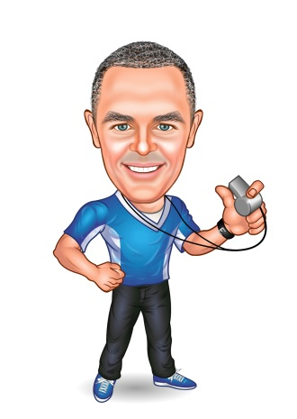
2.2 PERSONAL – Goals for 2022
Now it’s time to get specific and list some ‘non-business’ goals for 2022. Remember to review what needs ‘carrying over’ from the 2021 ‘Fall Short’ list.
Be specific here. If you want a ‘holiday’, you should define where and when, along with a budget.

Some ideas to get you started might include:
- Fitness / weight goals
- Write a book
- Investing & Passive Income
- Family time or activities
- Holidays / Vacations / Travel

2.3 BUSINESS – Goals for 2022

Now, make a list of all you want to achieve in the business for 2022. These are not the ‘results’, or ‘routine’, but rather the big ‘actions’ and ‘strategies that have results as their outcome.

BIG WIN for 2021
What was your biggest win for 2021? What challenges did you face, how did you overcome them and what most importantly did you learn about yourself?
Remember that challenges are always opportunities to learn and grow!
Write a couple of paragraphs below recapping your year!

2.4 Monthly Action Steps for 2022

Now it’s time to set your year in advance! Record the action projects
that you commit to for that particular month. Planning ahead is essential for success! If you give your attention to one particular project each month, that will build momentum to a successful year.
“Accomplishment equals Success!”

Project Introduction | Action Steps / Who
JAN:
FEB:
MARCH:
APRIL:
MAY:
JUNE:
JULY:
AUG:
SEPT:
OCT:
NOV:
DEC:

2.4 Rewards for 2022

Now it’s time to define your ‘rewards’! Record the projects and goals
that you want to reward yourself for to the table below.
Be sure to also add a big fat juicy reward. It’s important, that if you
don’t achieve the goal… You don’t get the reward! See this Goal
as if it is already yours… See yourself enjoying the reward!
“Accomplishment equals Celebration!” Be sure to Celebrate!

Project / Goal | Reward on completion
15.

3.0 Commitment
Now it’s time to commit to the foundation of your plan!

Commitment Statement
Signed: _____________________ Date: _______________

Having defined my intentions for 2022, I commit to pursuing my goals with ‘proactive’ determination.
I will strive to become more self-aware when tempted by procrastination and distraction; and commit to ‘staying the course’ and doing what’s best for the long term.
If I do not complete a planned activity, or I experience an un-favorable outcome, I will always ask myself “how am I responsible?”
I will invest my existing resources on time, relationships, money and knowledge, to achieve my goals and reward myself when I do.
I give those who care for me, permission to help me on my quest, by holding me accountable to my commitment.

3.0 Commitment
Now its time to commit to the foundation of your plan!

Signed: Date: __________________

Having defined my intentions for 2016, I commit to pursuing my goals with ‘proactive’ determination.
I will strive to become more self-aware, when tempted by procrastination and distraction; and commit to ‘staying the course’ and doing what’s best for the long term.
If I do not complete a planned activity, or I experience an un-favorable outcome, I will always ask myself “how am I responsible?”
I will invest my existing resources of time, relationships, money and knowledge, to achieve my goals and reward myself when I do.
I give those who care for me, permission to help me on my quest, by holding me accountable to my commitment.

Commitment Statement

